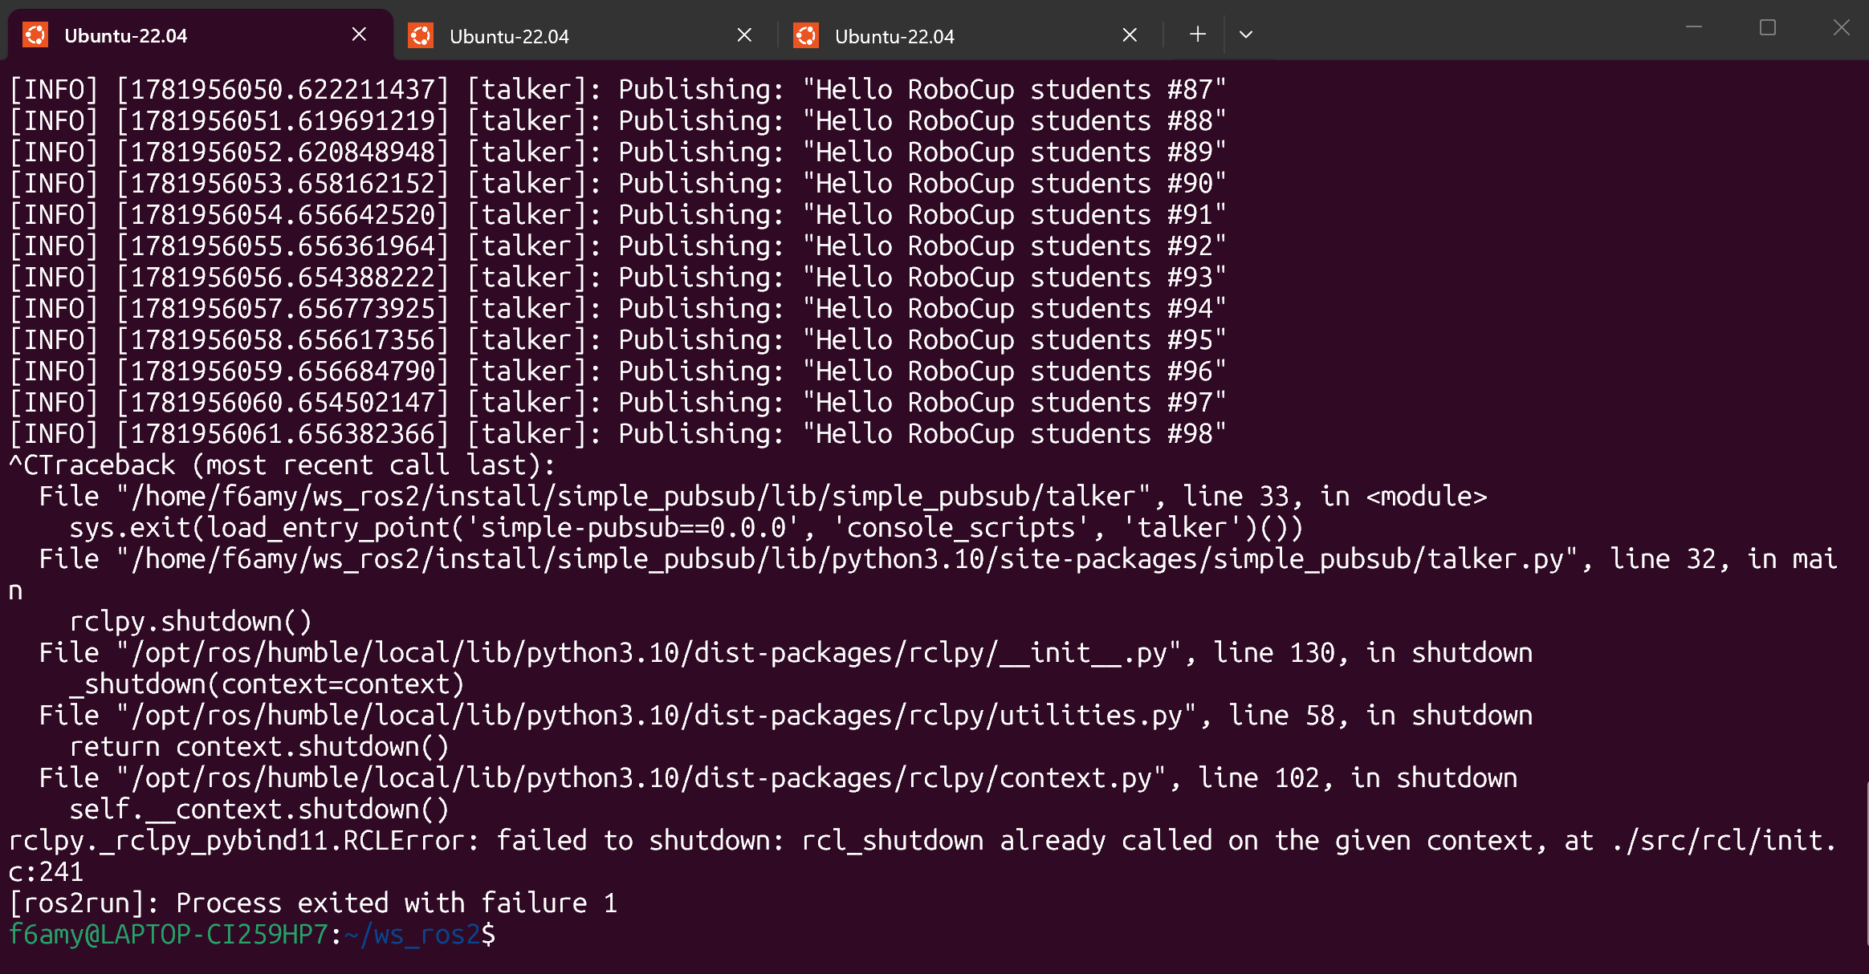

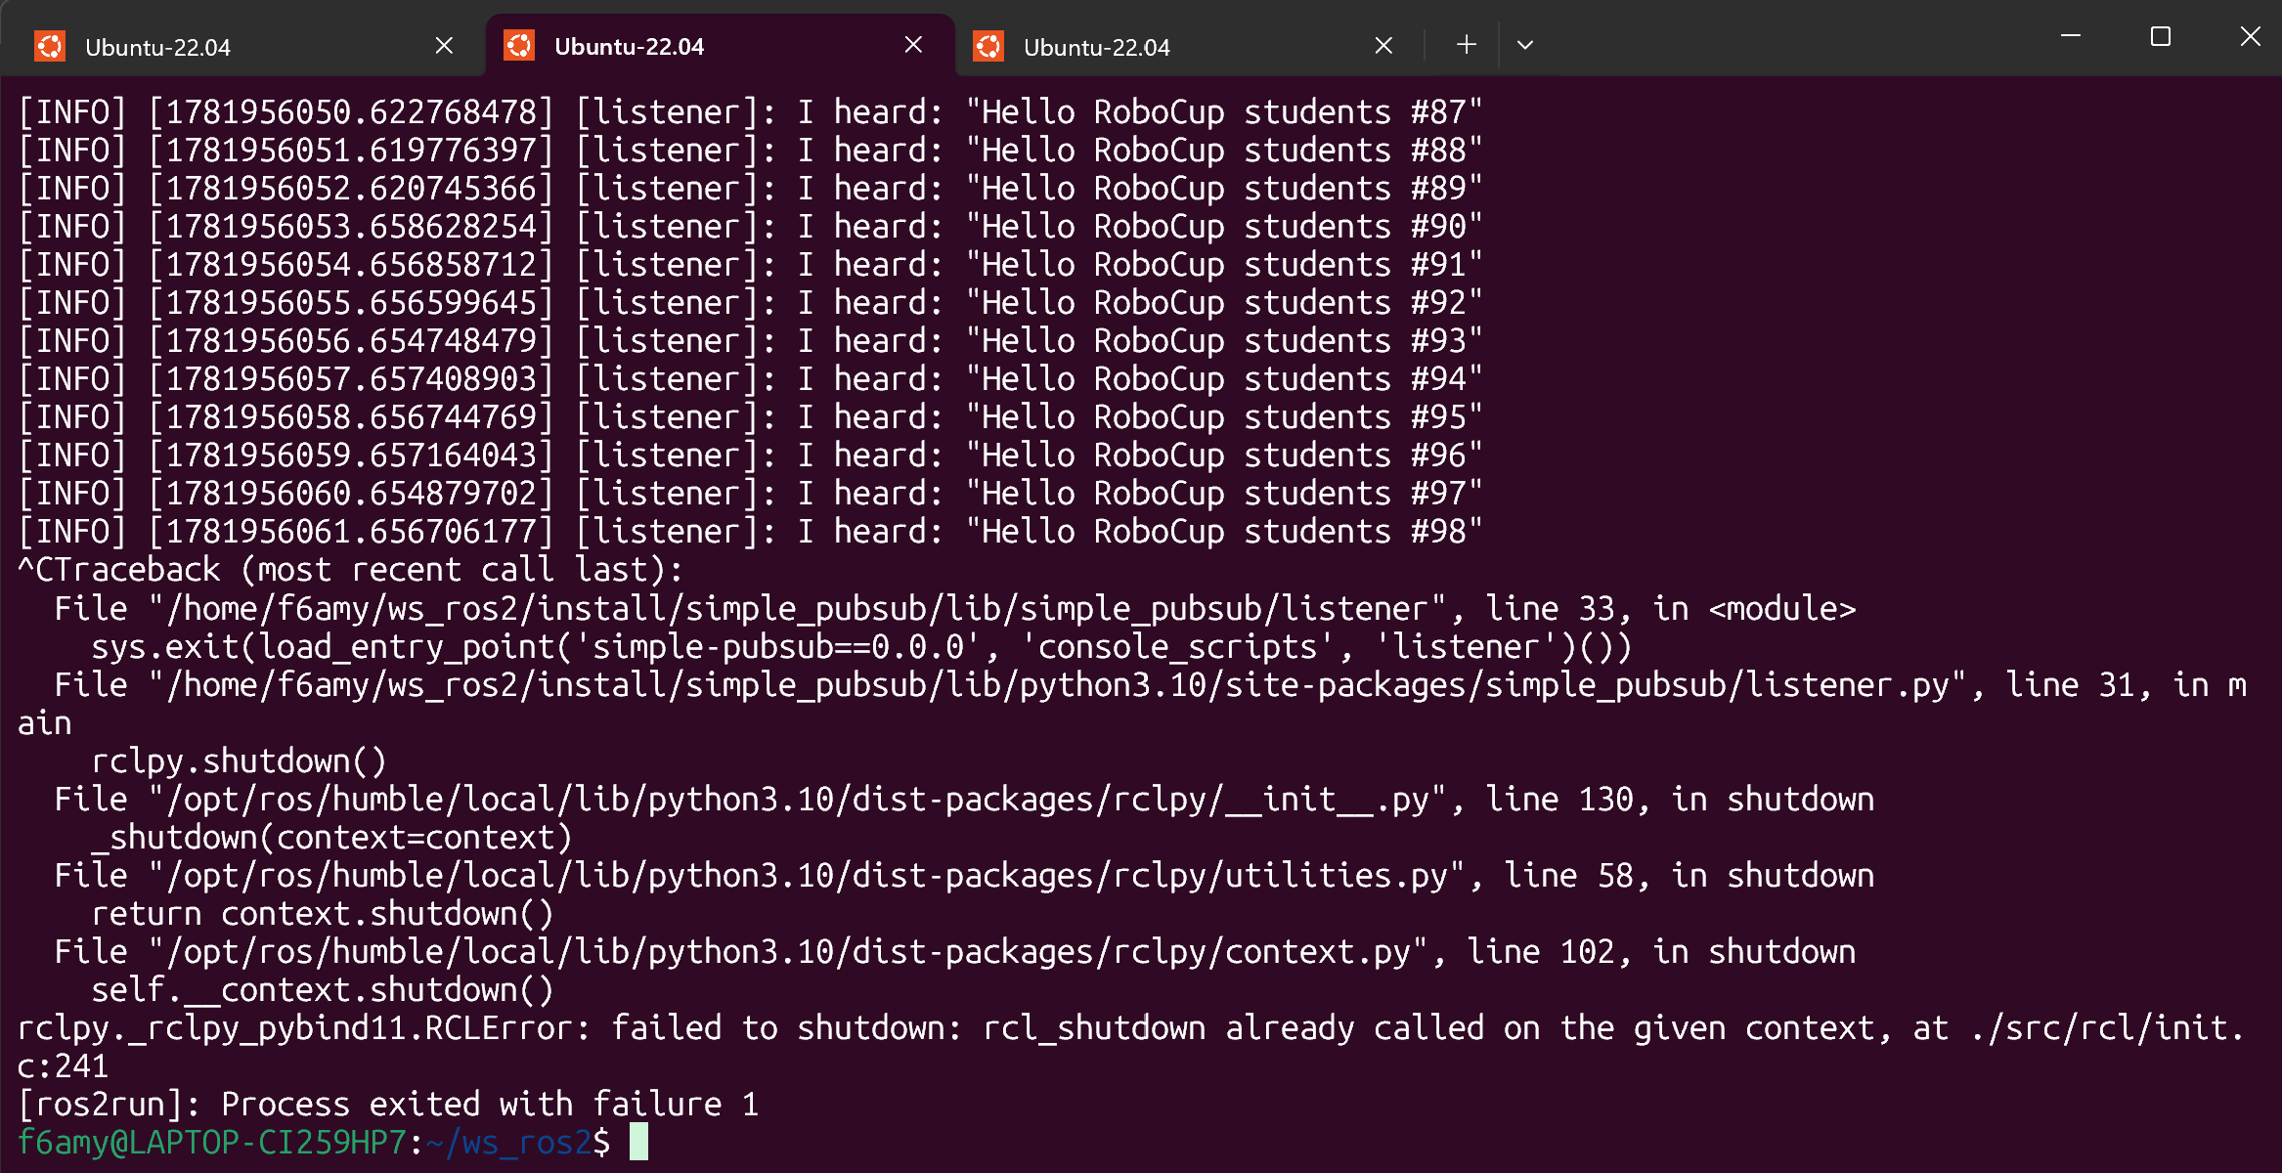
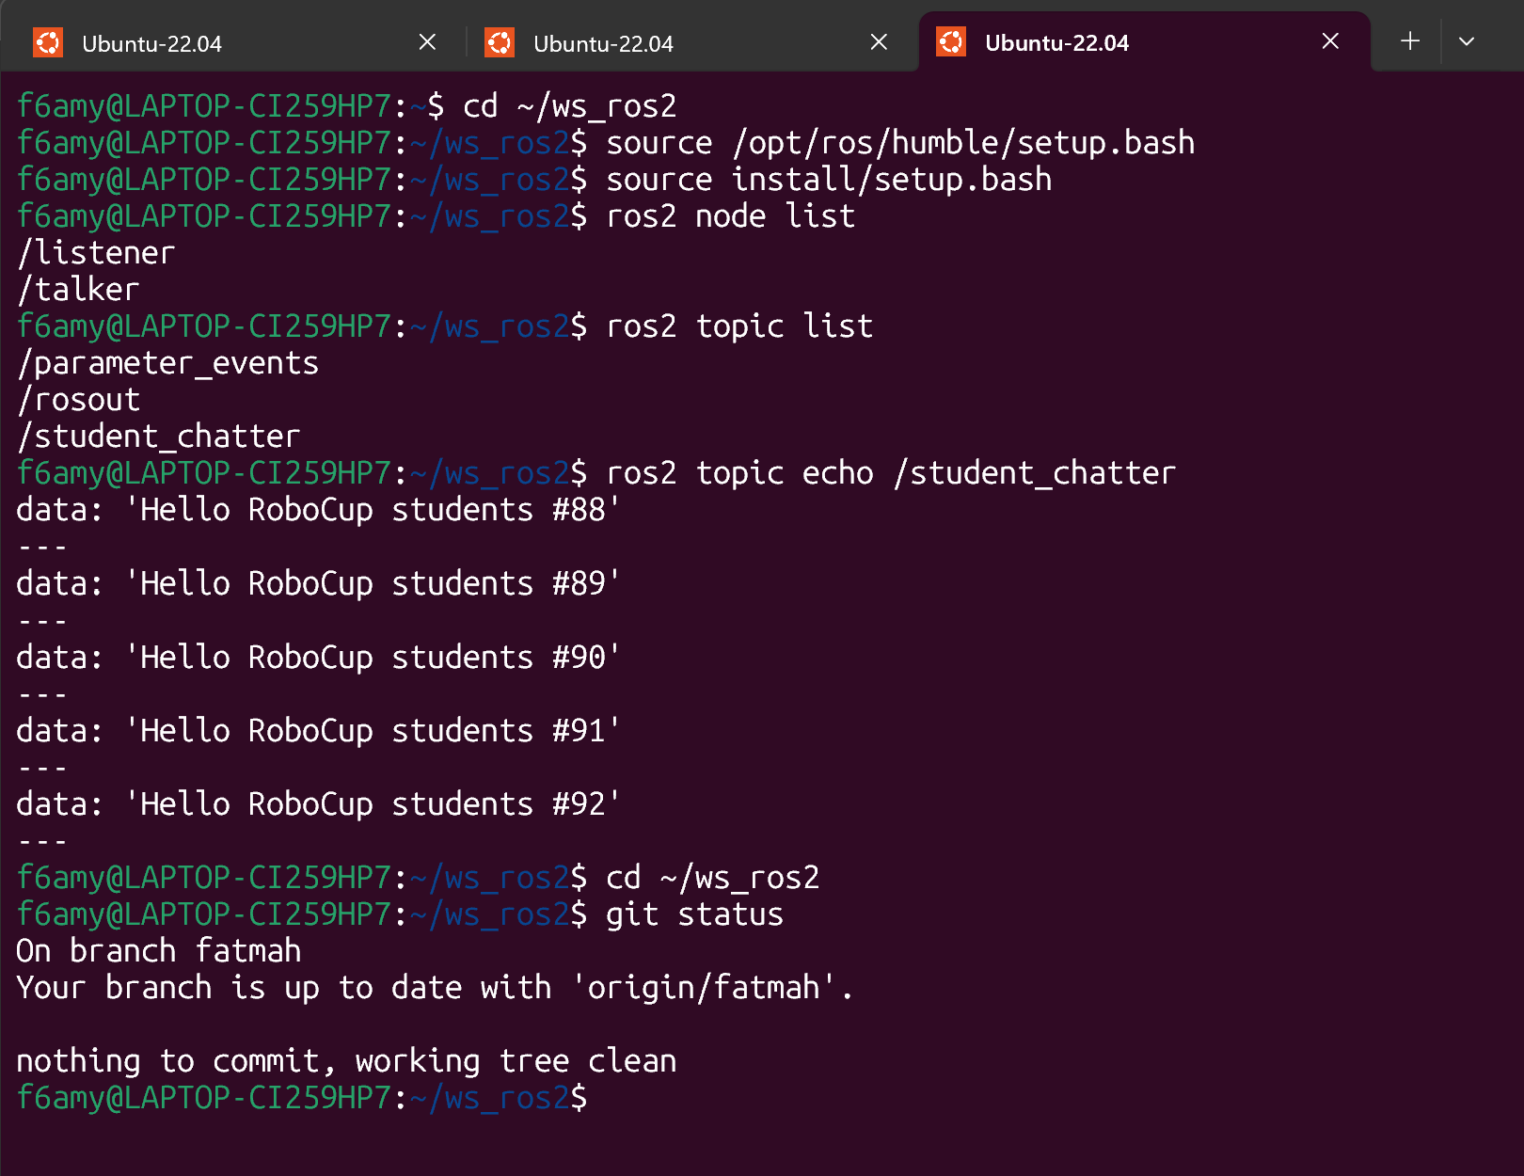
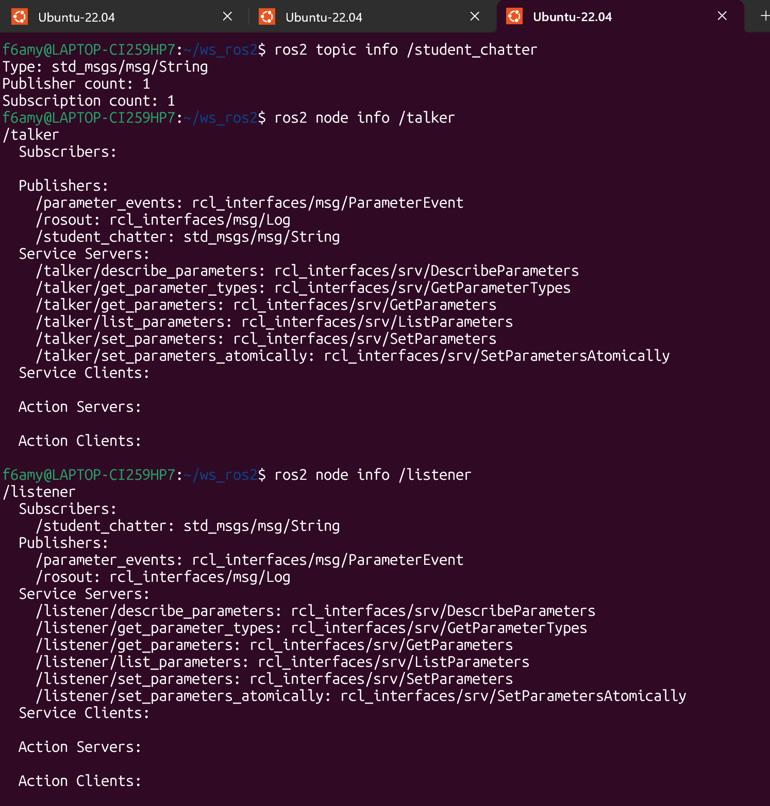
Branch name: fatmah
Required main task:
https://github.com/fatma11223344/ws_ros2/tree/fatmah

branch name: fatmah-extension
Extension exercizes:
https://github.com/fatma11223344/ws_ros2/tree/fatmah-extension

